36W UV Manicure Lamp
You are bidding on our 36 Watt UV curing lamp with excellent professional quality. This unit uses 4 powerful UV bulbs and features a built-in timer. The unit is professional for the shop and light enough to take along with you.

About the accessories
1
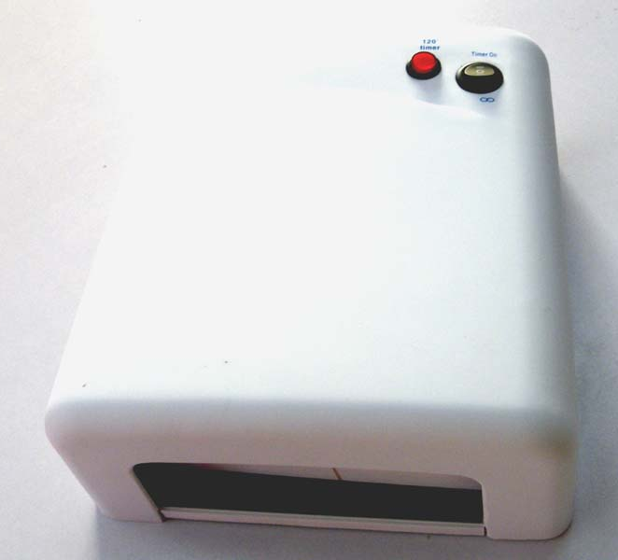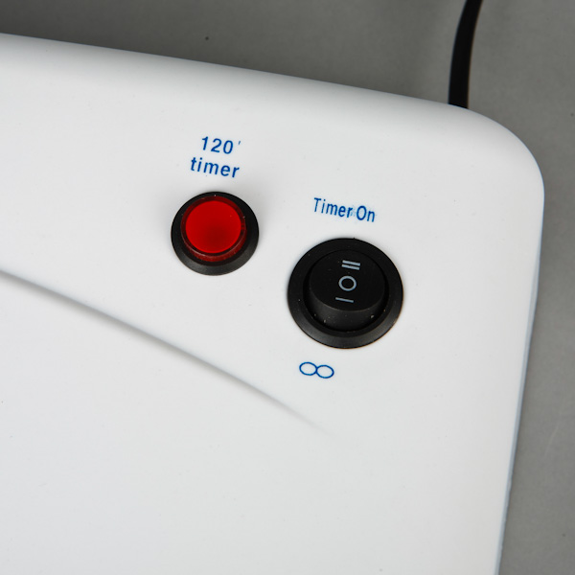
4
3
2
5
- On-off switch
- ∞（On）(pressing the On-off switch on this position, the UV lamp will turn on all the time）
- O (off)
- timer on
- 120” timer (timer starter) (pressing the On-off switch on “timer on” position and press this button, the lamp will shut off automatically after 120 second. )

Specifications
Voltage: 110v 60Hz
Timer: 120secs
Wavelength of highest peak=370.um
Power: 36w
Using 4pcs 9W UV Bulbs, please replace the bulbs regularly (about 6 month) for keeping the efficiency.
Net weight: 1.08kg
Measurement: 250*233*85mm

Operation of the product:
- Plug all four pieces 9W UV fluorescent bulbs into the lamp. The bulb has to pass through one clack (locks) before it is firmly secured.
- Connect the UV lamp to AC power (110V).
- By pressing the On-off switch on “∞”(on) position , the UV lamp will turn on all the time.
- By pressing the On-off switch on “timer on” position, and then pressing the timer starter “120’ timer”, the lamp will shut off automatically after 120 second. (Every time you press the button after setting the button to position “Time on”, the lamp will on and shut off automatically after 120 second.)
Basic curing nail operation for beginner
- Clean nails，then trim nail surface to be rough with the nail file as normal manicure process.
- Coat the nails with base gel and cure the nails with UV lamp for 30-60s, use remover to remove the sticky layer.
- Coat the nails with polish gel and cure the nails with UV lamp for 60-90s, you can give your nails a second coat of polish if need. Then grinding the shape of the nail you want.
- Coat the nails with the topcoat and cure the nails with UV lamp about 60-90s.

Note：
- How much time your need to cure a certain nail coat depends on the thickness and the nature of you UV nail polish. Practice makes perfect.
- Please replace the bulbs regularly (about 6 month) for keeping the efficiency.
- Use the correct power, read source voltage.
- Turn the light off once your notice unusual phenomena, such as smoke, stink, etc.
- Turn it off when changing the bulbs.
- Do not stare at the UV bulb directly for long time
- Do not pressing buttons including the timer button frequently in one service, which will cause damage to the UV lamp
- Keep the UV gel away from the lamp.

Package contents:
1 X 36W UV GEL Nail Curing Lamp Dryer (with 4pc lamp tube bulbs, US plug)

