Video Recording Borescope
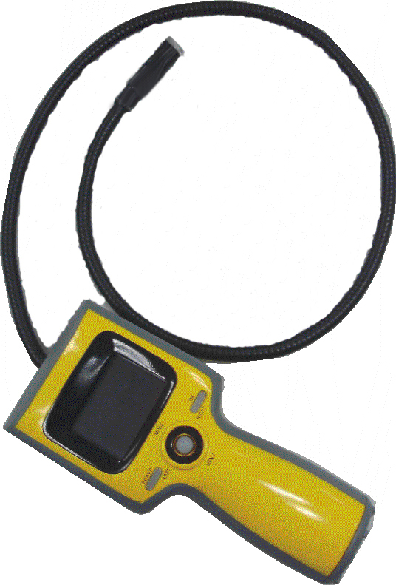

User’s Manual

FCC Statement

This device complies with Part 15 of the FCC rules. Operation is subject to the following two conditions:

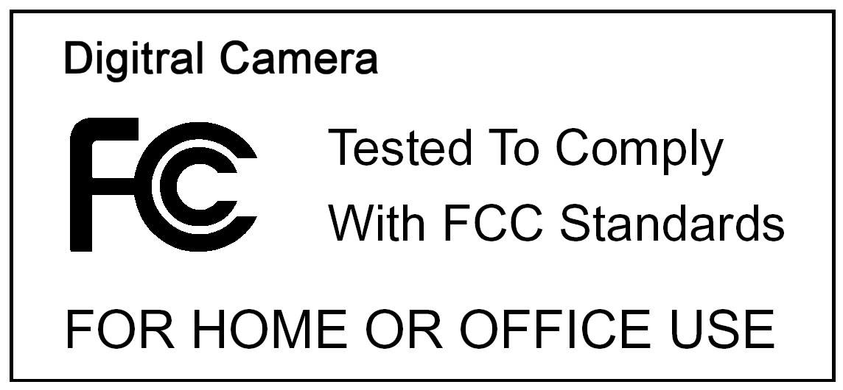
(1) This device may not cause harmful interference.
(2) This device must accept any interference received, including interference that may cause undesired operation.

NOTE: This device has been tested and found to comply with the limits for Class B digital devices, pursuant to Part 15 of the FCC rules. These limits are designed to provide reasonable protection against harmful interference in a residential installation. This device generates uses and can radiate radio frequency energy and, if not installed an d used in accordance with the instructions, may cause harmful interference to radio communications. However, there is no guarantee that interference will not occur in a particular installation. If this device does cause harmful interference to radio or television reception, which can be determined by turning the device off and on, the user is encouraged to try to correct the interference by one or more of the following measures.

Use of shielded cable is required to comply with Class B limits in Subpart B of Part 15 of the FCC rules.
Do not make any changes or modifications to the device unless otherwise specified in the manual. If such changes or modifications should be made, you could be required to stop operation of the device.

Table of Contents Page
1. Package Contents ----------------------------------------------------------------------------- | 1
2. Standard Equipment -------------------------------------------------------------------------- | 2
3. Display Information --------------------------------------------------------------------------- | 3
4.Assembly------------------------------------------------------------------------------------------- | 4
•To Install Batteries (4 AA) ------------------------------------------------------------------ | 4
•Inserting SD/MMC Card ------------------------------------------------------------------- | 5
5. Taking Pictures --------------------------------------------------------------------------------- | 6
• Taking a Picture ----------------------------------------------------------------------------- | 6
•Typical Applications ------------------------------------------------------------------- | 6
•Taking a Video ------------------------------------------------------------------------------- | 7
•Reviewing a Picture or video ------------------------------------------------------------- | 7
•Deleting a Picture or Video --------------------------------------------------------------- | 7
6. Customizing Your Optical Video Recording Borescope Settings ------------- | 7
* Capture Status Menu -------------------------------------------------------------------- | 7
*[Setup] Settings ---------------------------------------------------------------------------- | 7
*Playback Status Menu -------------------------------------------------------------------- | 9
7. Appendix --------------------------------------------------------------------------------------- | 10
8. General Safety Information----------------------------------------------------------------- | 11
Work Area Safety ---------------------------------------------------------------------------- | 11
*Personal Safety ----------------------------------------------------------------------------- | 12

1. Package Contents

Make sure that all of the items shown below are included with your Video Recording Borescope.

Optical Video Recording Borescope | 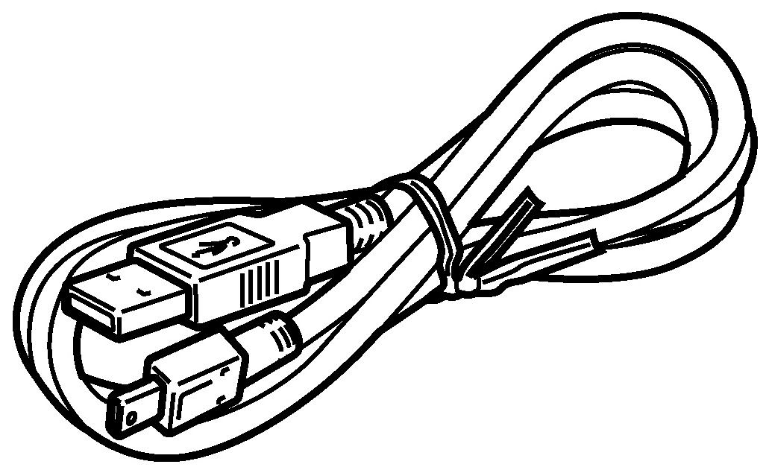  • USB cable | 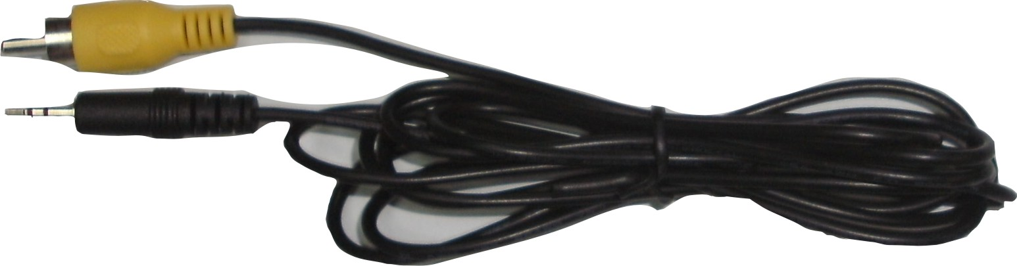  • Video cable
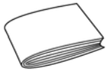

•User’s manual

2. Standard Equipment
The Video Recording Borescope comes with the following items:

1. LCD SCREEN
2. OK BUTTON
3. JOYSTICK
LEFT BUTTON; RIGHT BUTTON;
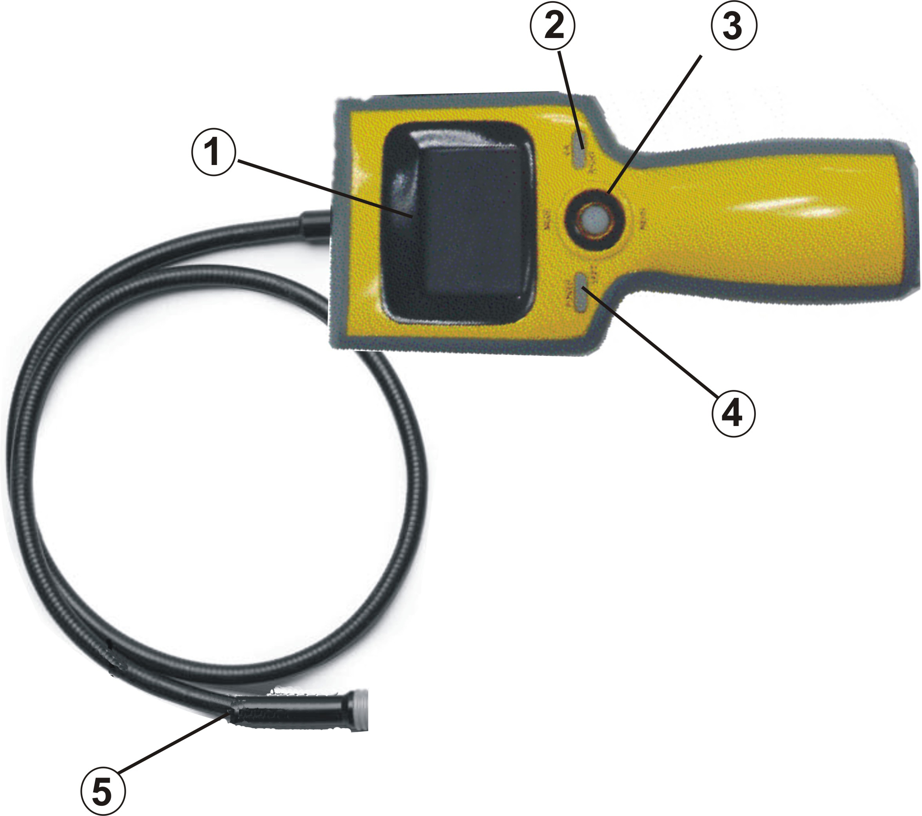
UP BUTTON (MODE);
DOWN BUTTON (MENU)

4. POWER BUTTON
5. IMAGER HEAD and CABLE

3. Display Information

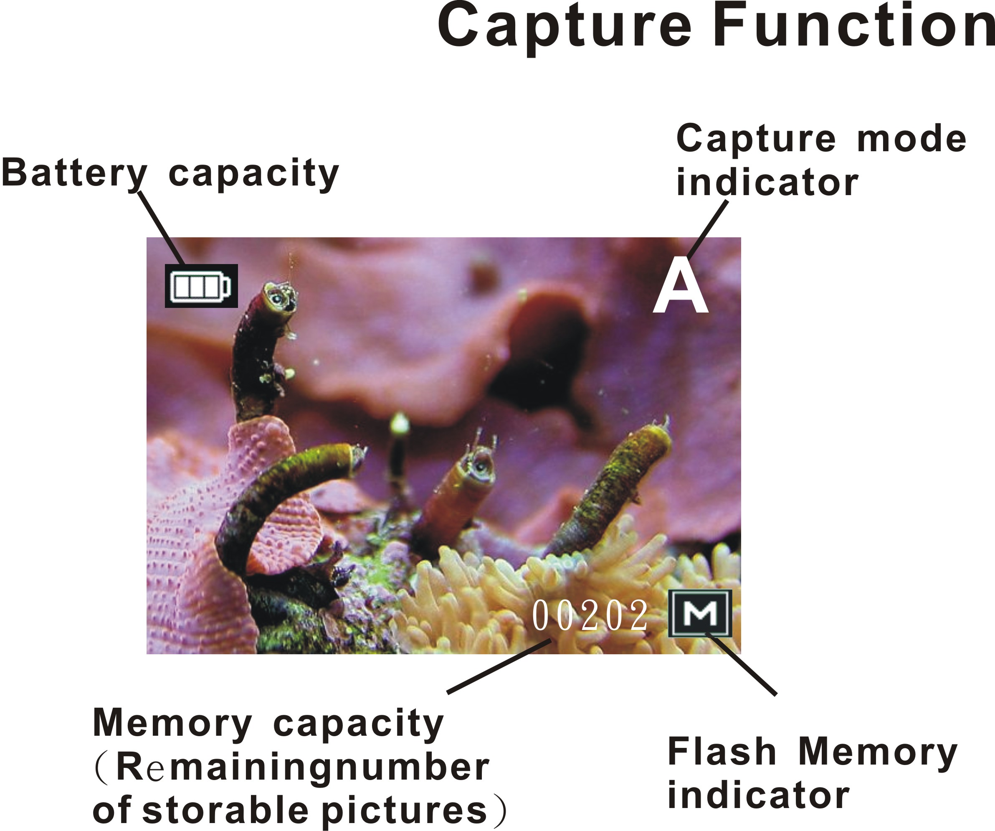

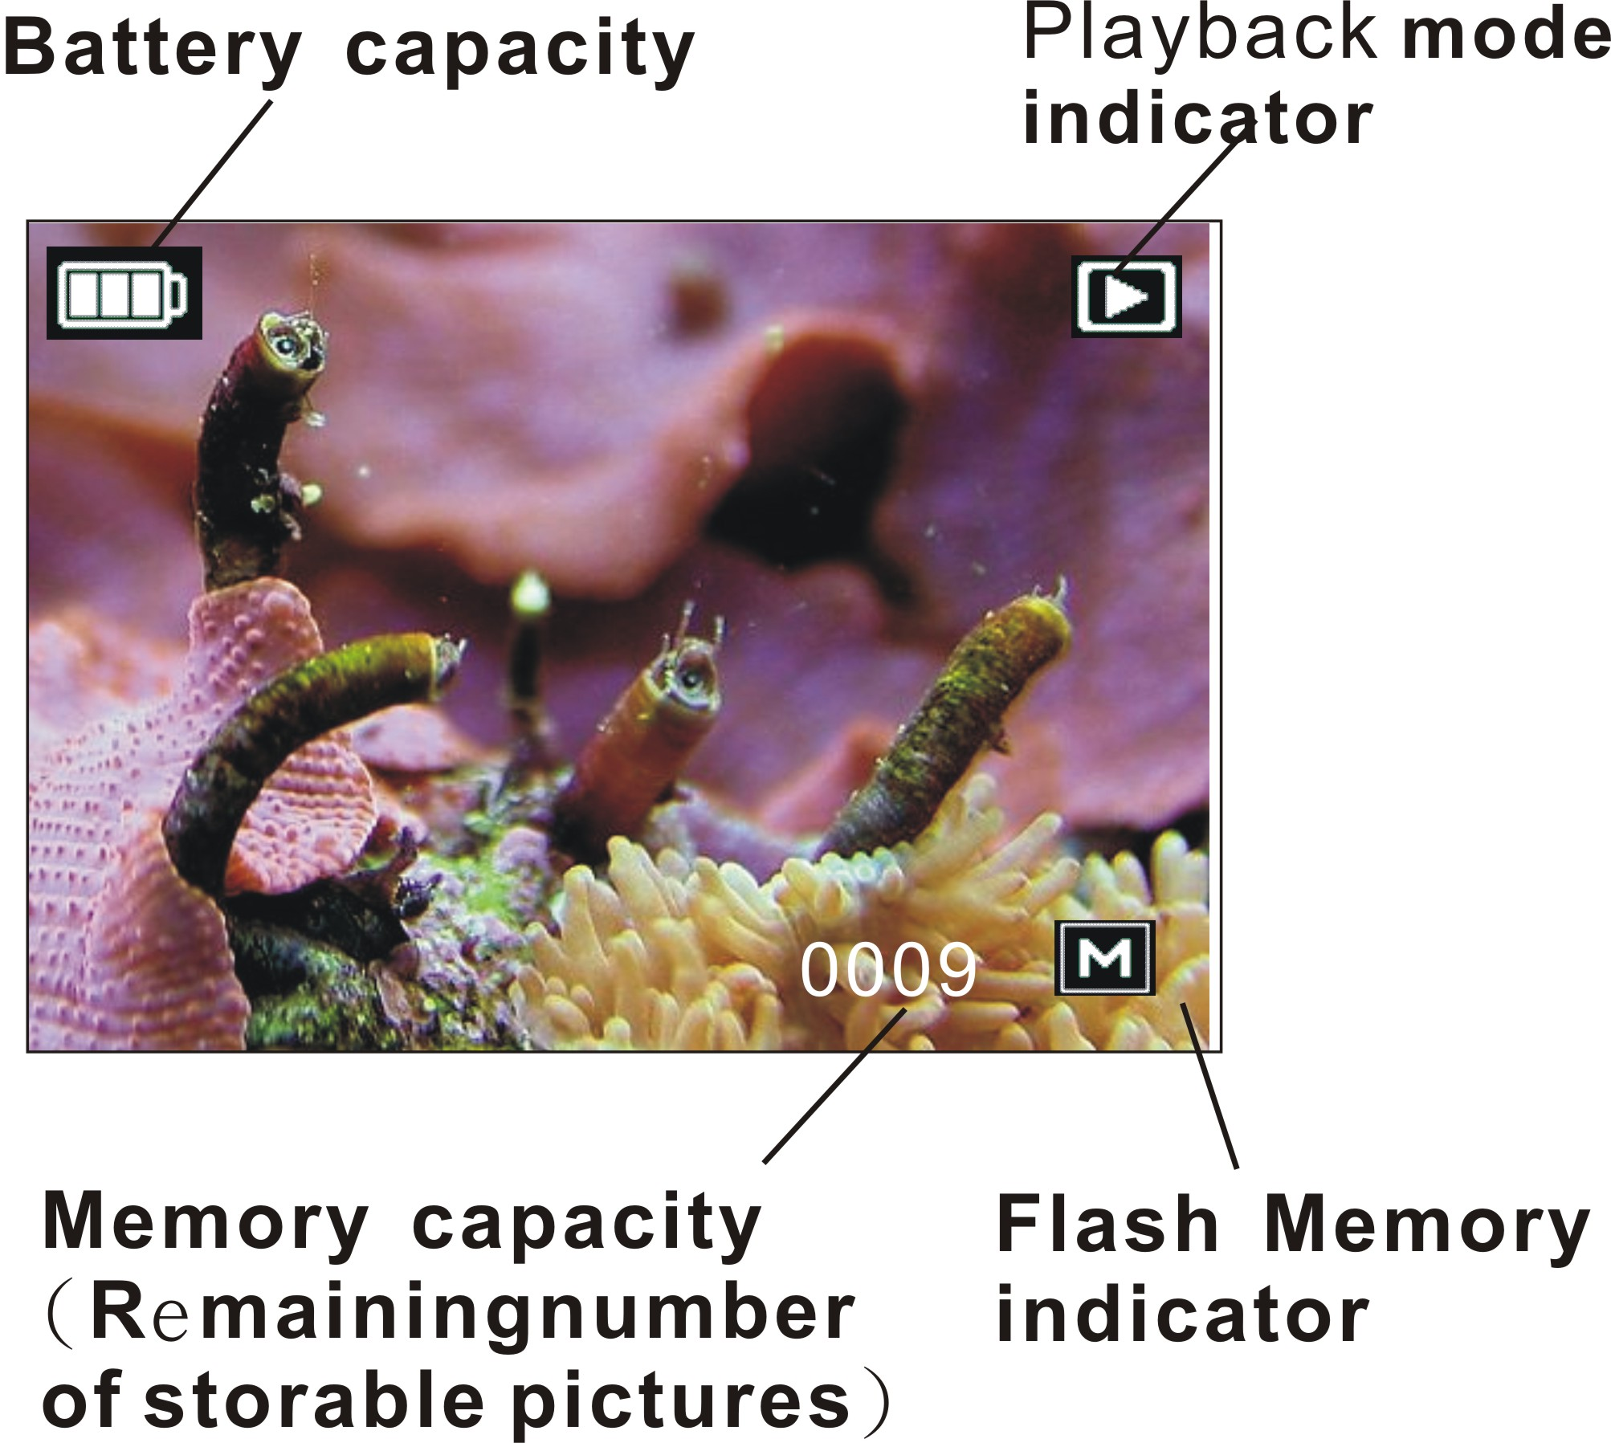
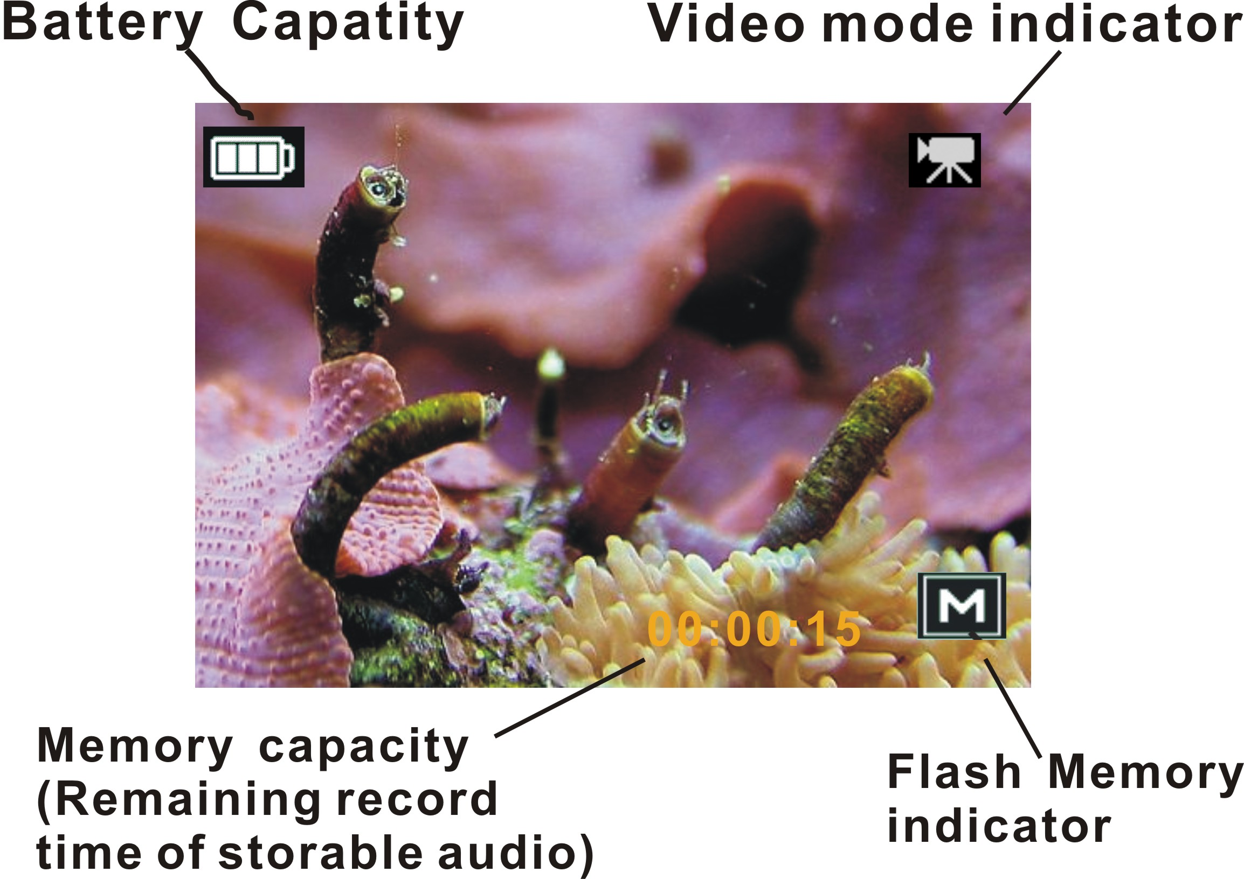

4. Assembly
To Install Batteries (4 AA):
NOTE! Be sure to read Battery Precautions section.
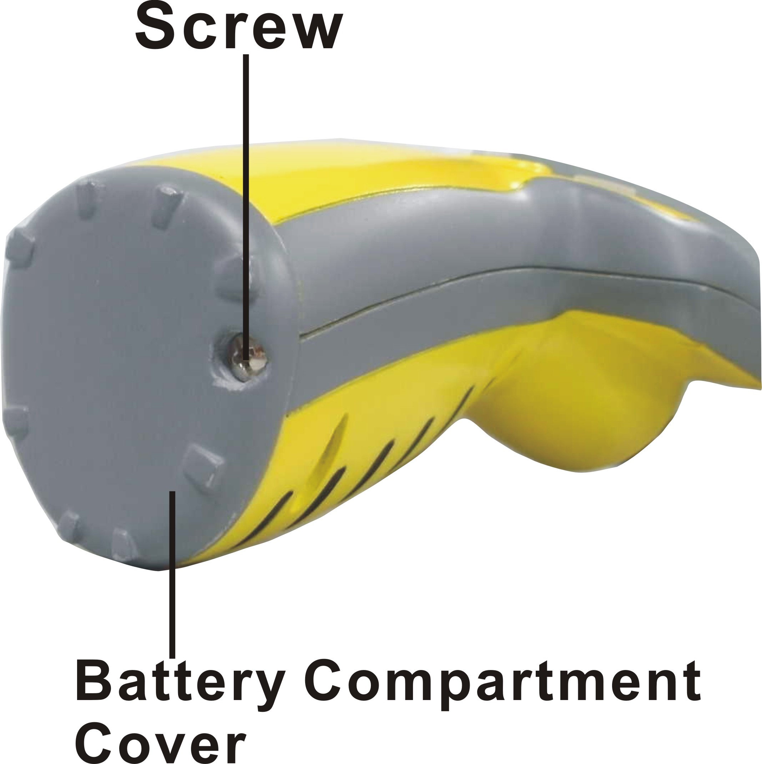
1. Turn the hand-held viewer upside down to expose the battery compartment cover and screw (Figure 1).

Figure 1
2. Using a Phillips head screwdriver, remove screw and cover.
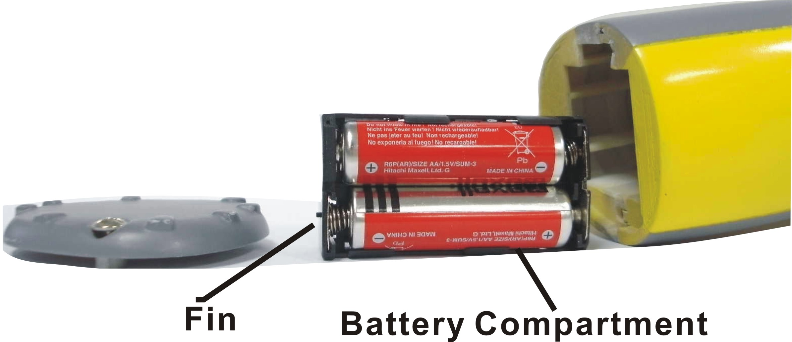
3. Remove battery compartment and insert four (4) new AA batteries into the proper slots in the battery compartment (Figure 2). Proper battery orientation is indicated on the battery compartment

Figure 2

4. Replace battery compartment, making sure the fin is oriented as shown with its taller portion toward the LCD screen.
5. Replace battery cover (Figure 1) and screw.

• Inserting SD/MMC Card:
This optical Video Recording Borescope offers SD card for storing files:
SD Card - Optional SD cards provide removable, reusable storage for pictures and videos. Store as many pictures as you like, depending on the size of the card.
CAUTION:
• The card can only be inserted one way; forcing it may damage the Video Recording Borescope or card.
Do not insert or remove a card when power is on.

1. Turn the Video Recording Borescope off.
2. Position the card as shown. Push the card into the slot
until it hooks up.
3. To remove the card gently push the card until it get released
from the hooking mechanism. After it has pooped out pull it
out completely.

Note: 1.If the SD card is present in the optical Video Recording Borescope and then the
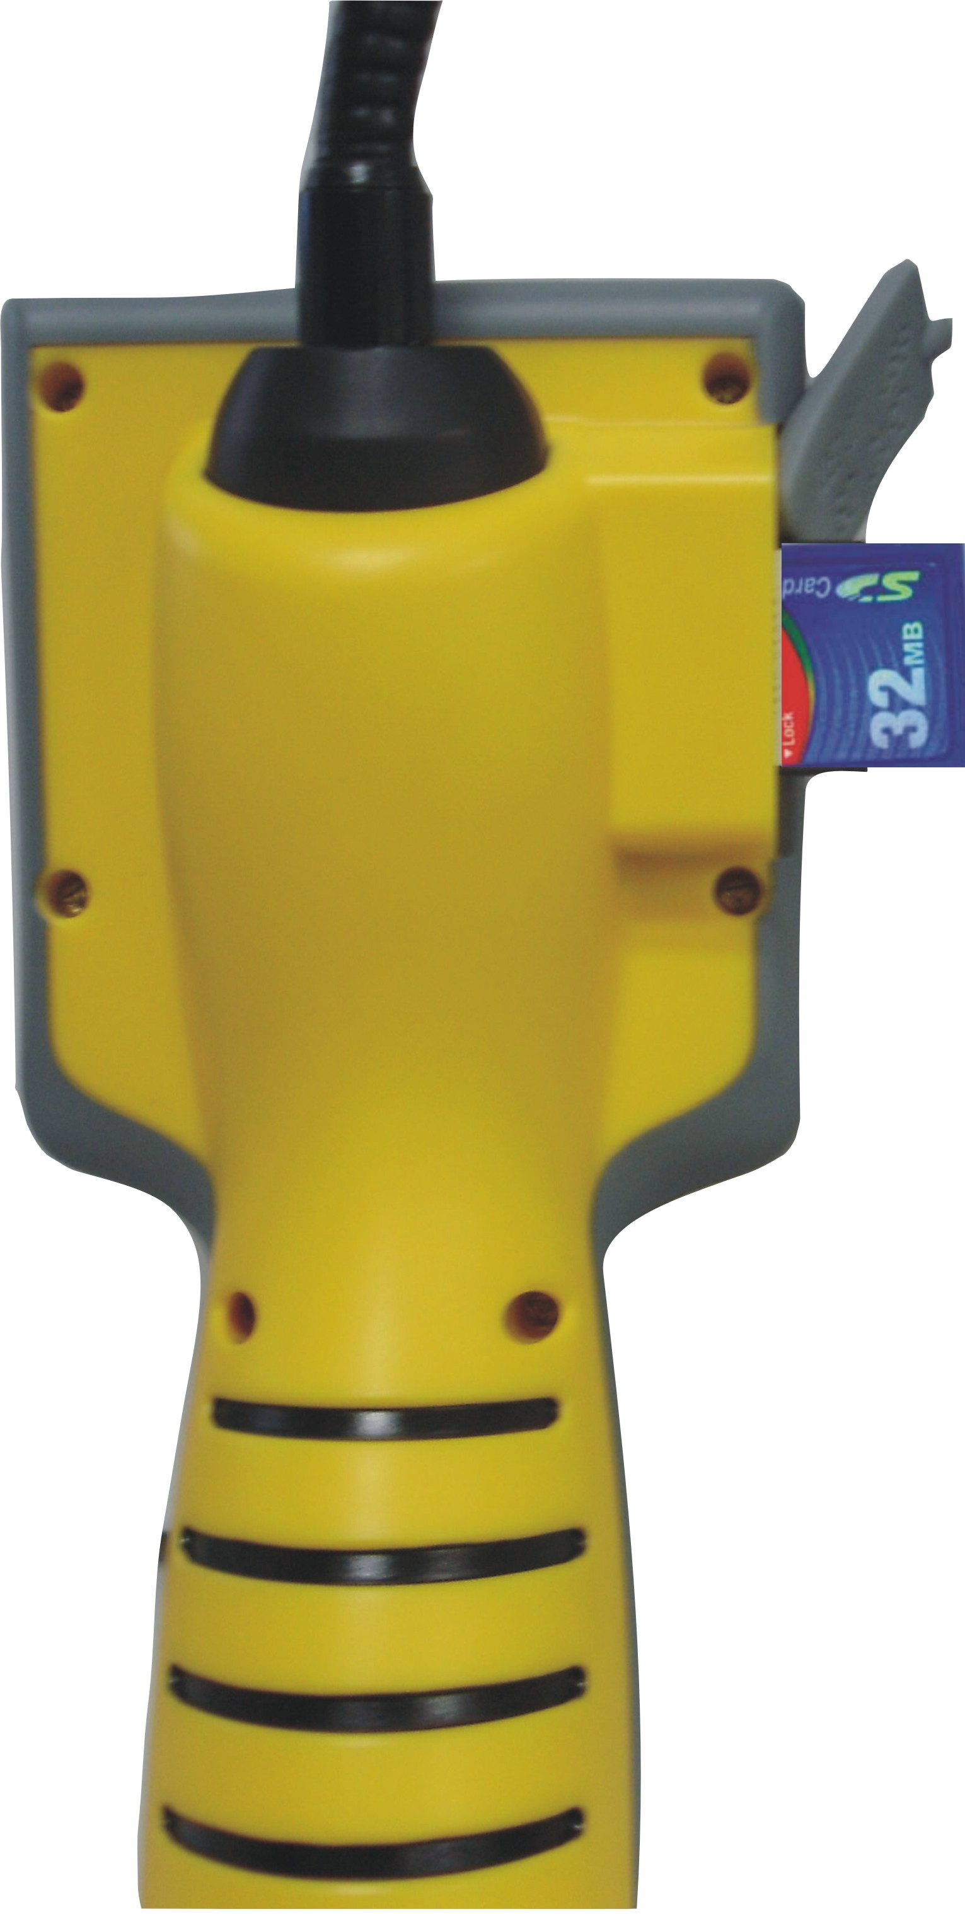
picture/ video will save in the SD card.
2. If the “CARD FULL!!!” warning message shows on
the LCD screen, it means the SD card is full. Please
remove the memory and insert a new one.

5. Taking Pictures
• Taking a Picture
1.Turn on the Optical Video Recording Borescope.
2. View the objects through the LCD screen.
3. Holding the Optical Video Recording Borescope still, press the OK button to take a picture.

• Taking a Video
1. Turn on the Optical Video Recording Borescope.

2. Rock the JOYSTICK: UP BUTTON (MODE) enter the (default).
3. View the subject through the LCD screen.
4. Press the OK button to take a video; press the OK button again to stop recording.
Note: 1.The maximum length of an individual optical Video Recording Borescope clip depends on memory size. Use a higher capacity SD card will record longer movie clip.

2.Optical Video Recording Borescope recording stops automatically when memory is full.

• Reviewing a Picture or video
1. Turn on the optical Video Recording Borescope.
2. Rock the JOYSTICK: UP BUTTON (MODE) to enter the ► (playback status).
Press the ◄ / ►to select the picture or video to review on the monitor screen
3. Press the button to exit reviewing mode

• Deleting a Picture or Video
1. Turn on the optical Video Recording Borescope, rock the JOYSTICK: UP BUTTON (MODE) to enter the ► (playback status).
2. Rock the JOYSTICK: ▼ DOWN BUTTON (MENU), and rock the ▲ or ▼ button to select the Delete icon, press the OK button to confirm. Rock the ▲ or ▼ button again to select the Single/All/Select. Press the OK button to confirm. Press the ◄ button to exit.
6. Customizing Your Optical Video Recording Borescope Settings
* Capture Status Menu
[MENU BUTTON]
When user in photo mode. Rock the ▼ menu button, press the ok button .Use ▲and ▼ to select Off/Date Only /Date &Time item, press the ok button to confirm. User can set the time and date. Rock the ◄ button to exit.
[Time Stamp]
 | OFF | Do not print time on the picture.
 | Date Only | Print Date on the picture.
 | Date & Time | Print Date & Time on the picture.

*[Setup] Settings
When user in photo mode. Rock the ▼menu button, Use ► buttons to enter the Setup items. Use ▲and ▼ to select the item, press the ok button to confirm the setting. Rock the ◄ button to return to capture status.

[Format]
Cancel | Do not format the flash memory or SD card.
Execute | Format the flsh memory or SD card.

[Beep]
ON | Setting the beep sound to on.
OFF | Setting the beep sound to off. (*)

[Auto Off]
1MIN | Setting the optical Video Recording Borescope automatically powers off approximately 1 minute.
3MIN | Setting the optical Video Recording Borescope automatically powers off approximately 3 minutes.
5MIN | Setting the optical Video Recording Borescope automatically powers off approximately 5 minutes.
Off | Setting the optical Video Recording Borescope always on.

[Sys. Reset]
Cancel | Do not recover to system reset.
Execute | Recover to system reset.

[TV Output]
NTSC | Setting the TV Output to NTSC.
PAl | Setting the TV Output to PAL.

[Date Input]
Off | Do not input the time on the file.
Set | Input the time on the file.

[USB]
PC Cam | You can use it in PC-Cam mode
Disk Drive | You can use it to storage pictures and videos.
Printer | You can print directly to USB port printer. Only available at playback mode.

*Playback Status Menu
[Delete]
Single | to delete (erase) current file.
All | to delete (erase) all files.
Select | to delete (erase) the selected file by viewing the file as a thumbnail.

[Slide Show]
3 Sec | Setting the slide show time to three seconds.
5 Sec | Setting the slide show time to five seconds.
10 Sec | Setting the slide show time to ten seconds.

[Protect]
If you want to unprotect the file, please choose cancel and then press the OK button to confirm the setting.

Single | To protect the current file.
All | To protect all files.
Select | To protect the selected file by viewing the file as a thumbnail. Press the menu button to return to view mode.

[Thumbnail]
Press the OK button to see the files in the thumbnail mode and then press the menu button to view the file in the whole LCD screen.

[Volume]
Adjust the volume from 1 to 8.

7. Appendix:

Specifications

Image Sensor | CMOS 510 x 492 (250K pixels), Sensor area 1 /4"
Lens Specification | F 2.8, f =4.3 mm, View angle 63-70°,
Visual Distance Range | 20mm-280 mm (recommend 100mm)
Light Source | 2 white LED light with adjustable light intensity
Waterproof | Common water resistance
Display | 2.4” TFT-LCD Screen
Power Supply | Battery alkaline “AA”1.5V X 4
Storage | 32MB built-in and SD card slot
Output | TV out and mini USB (B type)
Dimension (L x W x H) | 1140*95*150mm(flexible snake length 960mm)
Weight (g) | About 753 g

8.General Safety Information ：

WARNING! Read and understand all instructions. Failure to follow all instructions listed below may result in electric shock, fire and/or serious personal injury.

SAVE THESE INSTRUCTIONS!

*Work Area Safety
1．Keep your work area clean and well lit.
Cluttered benches and dark areas may cause accidents.
2．Do not operate electrical devices or visual inspection tool in explosive atmospheres, such as in the presence of flammable liquids, gases, or heavy dust.
Electrical devices or visual inspection tools create sparks which may ignite the dust or fumes.
3．Do not use the visual inspection tool around corrosive chemicals.
Exposure to corrosive, oily environments can ruin the plastic covering on the imager head and ruin the picture quality.
4．Keep bystanders, children, and visitors away while operating visual inspection tool.
Do not let visitors contact the unit

*Personal Safety
1. Stay alert, watch what you are doing and use common sense.
Do not use visual inspection tool while tired or under the influence of drugs, alcohol, or medications. A moment of inattention while operating tools may result in serious personal injury
2. Do not overreach. Keep proper footing and balance at all times.
Proper footing and balance enables better control of the tool in unexpected situations
3. Use safety Device.
Always wear eye protection. Dust mask, non-skid safety shoes, hard hat, or hearing protection must be used for appropriate conditions.
4. Use proper accessories.
Do not place this product on any unstable cart or surface. The product may fall causing serious injury to a person or serious damage to the product.
5. Prevent object and liquid entry.
Never spill liquid of any kind on the video display unit. Liquid increases the risk of electrical shock and damage to the product.
6. Do not use this device for personal or medical use/inspection in any way.
7. The unit is not shock-resistant.
Do not use it as a hammer or drop it.

